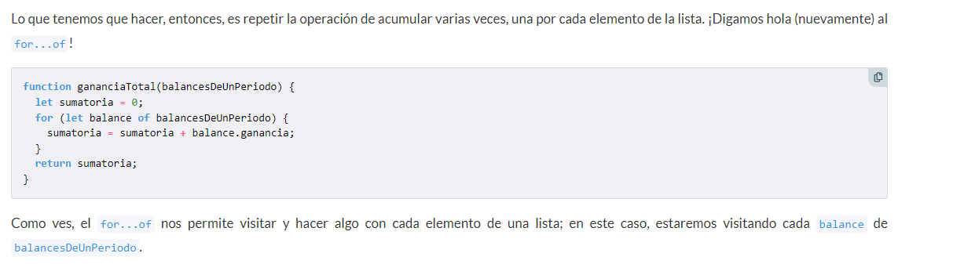

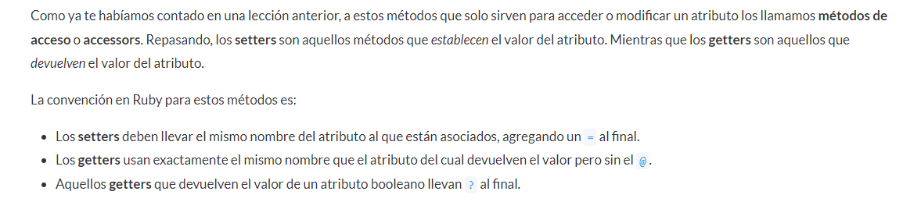

<https://www.youtube.com/watch?v=CvRxKLi_HO8&t=2112s>

